ANNUAL NEWS LETTER
JULY 2015 - JUNE 2016
Reach Out Trust Office
10, SamatadeepBldg, Gr. Floor Aruna, Kendra Dolarpada Girgaum–
25th Road, Bandra (W), Talasari Dist. Palghar Maharashtra
Mumbai -400 050, India India

The Reach Out Trust had educational and social activities as its main thrust in the last year. In education, our focus is school children and vocational training for youth. In social development, we have included women’s environmental and health issues. Sustainability both for the community and Trust activities are also our concern. Coordinating with the government; non government agencies, staff training and cultural promotion are other activities.

Our target area is Talasari W 150kilometers N of Mumbai in the state of Maharashtra, a tribal belt of mainly Warli tribes.

Education: Since many years we are assisting the PushpaVidhya School, a village school of Dhangadpad Zari in Talasari West. It has students both in the middle school Class I to 7th Grade and high school from class 8 to 10th GradeThis is the first year the childrenof the high school have appeared for the State Board Exam (S.S.C.) The teachers and students have been striving earnestly to get good results in their first batch of students. The results of this exam were in June and 85 % of the students were successful with the highest scoring 75%
This year in June 237 children have registered and 27 are in the 10th grade There are 10 teachers taking the various subjects including Languages, Maths Science and Physical Training Some of the other activities of the school were sports, excursions, art and cultural activities. They celebrated Teacher’s Day, Independence Day and Yoga Day. They had prayers for Adolf Tragler on the 26th August 2015 Dr Tragler attends to some of the health needs on her visits Children are dewormed and given vitamins and nutrition supplements .
.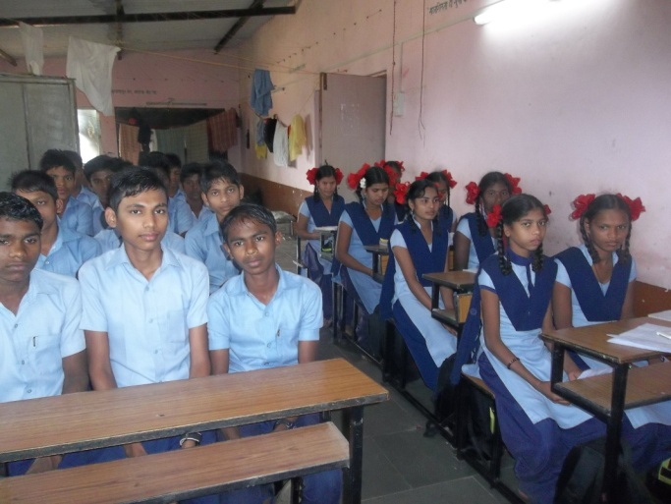 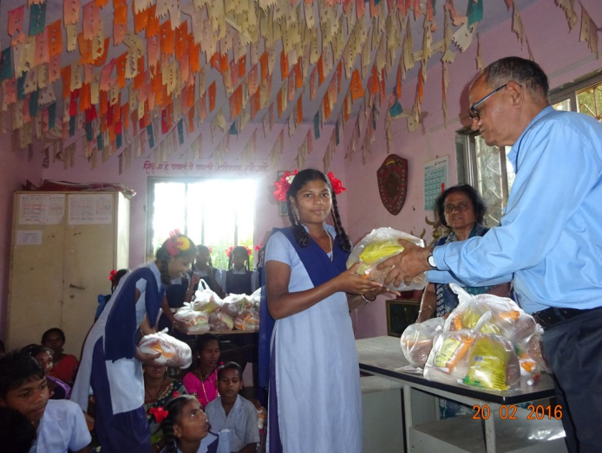

A survey was conducted regarding socio economic background of the high school children. Most of the families have 1-2 acres of land where they cultivate only a single crop of rice. The youth work in the nearby industrial areas where they get jobs on daily wages. The other jobs taken up by adults are in the farm and fruit orchards in the neighborhood. Home visits were made to the very poor families most of whom had half acre or no land. The 20 families identified from the survey were assisted with food items of good nutritional value. The older children in the school tuition program were also given nutrition supplements. Fruits from the Reach Out farm are also given regularly to the children.

Special attention was given to Santosh Gavad who had a neck deformity. He was taken for an orthopedic consultation and various investigations like X-ray and MRI were facilitated through the Trust. Medication helped to relieve the pain but he has been referred to Wadia Hospital, Mumbai for further treatment as he has a mass in the spine.
There were 3 other handicapped children including a 11 year old girls with spasticity of all 4 limbs
Fr Andrew &Sr Marie Trustees take special interest in the school activities on the monthly visits
This year the Rotary Club assisted the school in the computer program They provided the 6 laptops, a printer, a Xerox machine. Required soft ware ,internet connection and 2 teachers for training the children according to the curriculum prescribed to the school
This year we also assisted urban school children in the vicinity of our urban office in Bandra The girls were mainly from St Joseph’s convent school and the boys from St Thresa’s school The financial assistance was for school uniforms and books Most of the children were from migrant tribal families working as daily laborers

Vocational Training
. We have had 4 batches of students with six months training in tailoring and welding. All the students are now either self employed or have secured jobs in the industries in the vicinity .The tailoring students apply for machines at a discount from the local government. One student was donated a sewing machine as he came from a very poor family. Sunil Correa co-ordinates the technical program and is very busy with recruitment and job placement of the students .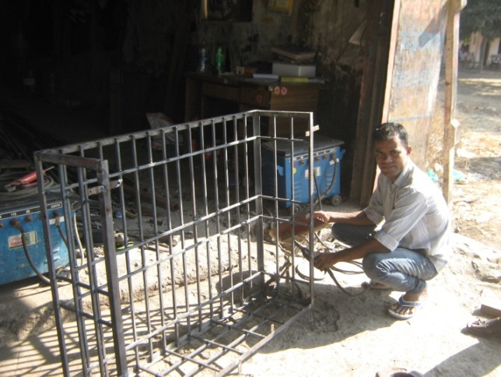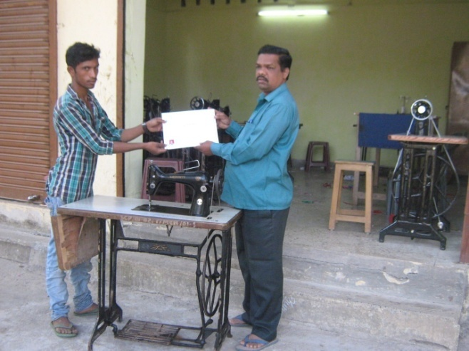
We also placed some of the students in the industrial belt They were to be further trained in tailoring and then to be employed by the firm
Women’s and Health Activities: We encourage the women to form self help groups. In the Dolarpada village, Sanu Rade our Activist has 20 such groups. Our Social Worker Dayanand attends some of the meetings Women have saving accounts, and most of them save at least Rs. 100/- per month. Internal loans with interest are given to the group members. This year the government has assisted the women in poultry schemes.Most of the women have invested in about 100 chickens 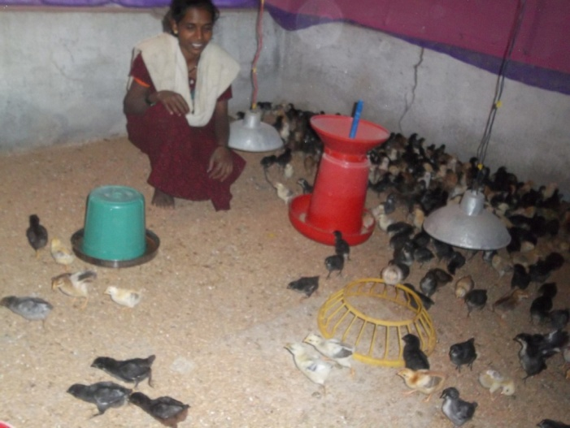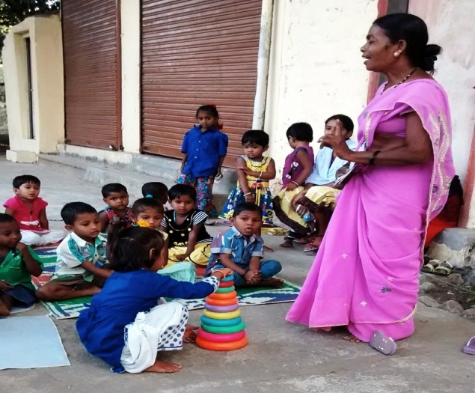
Other women have small tailoring units or shops at home. Sanu Rade is a trained nursery teacher and she conducted a nursery for the tiny tots in the afternoons.
Womens health and School heath are part of the program
In the urbam slums too families with chronic health problems like Cancer & Aids were given assistance Mamta & her husband and one child all were HIV positive They are being assisted financially in the program So also Bindu a widow with 4 children in school was helped financially. We assisted school and stay admission in a the YMCA shelter home for the 2 boys The girls were in a boarding school too Home visits are carried out regularlyA patient requiring Dialysis was assisted We intend to continue this Sponsership Program for Familes in need t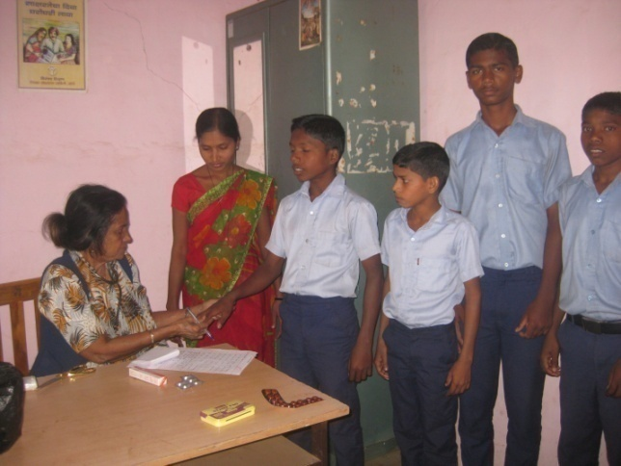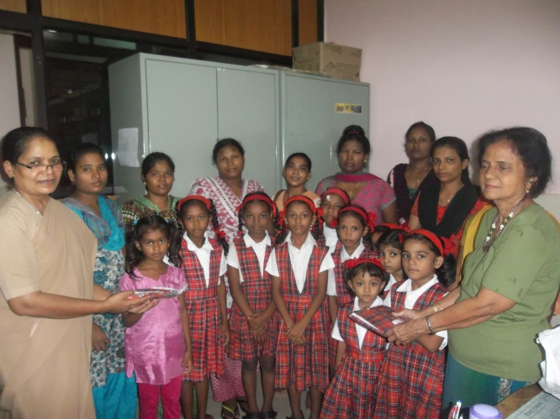
Environment: Water is a scarce resource and the people have to walk long distances to get water. The government has provided some bore wells. Our Trust has built a water tank on its premises from which some villagers fill up water. We hope to co-ordinate with an NGO to provide 20 bore wells in the surrounding villages. Surveys were conducted for this to choose the right location where water is scarce

Trust Land
On the Trust land we are sold some teak trees which were almost 20 year sold. There are many government formalities for this and this brought down the price to lower than our expectation. We have planted more trees on the borders now
Some sale from the fruits chickoos and mangoes continues. We are coordinating with the neighboring parish in Umargav in our activities.

There were repairs and painting of the offices and welding training center. The compound fencing needs constant repair. But fences are no barrier to the locals. They are always attempting to make use of fruits,firewood and have even committed thefts of Trust Property We have a horticulture plot of growing Mogra.a sweet smelling Jasmine like flower.
SPECIAL THANKS:
We give thanks to all our well-wishers and donors for their interest and donations to our projects. 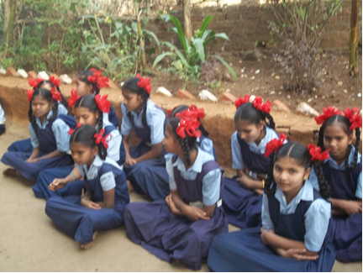Without support these projects would not have succeeded. Our appreciation and gratitude also goes to our family members and friends. Special thanks to:

Drs. Wolfgang & Barbara Sietz (Germany
Mrs. Regine Proebsting, Gaby and Willem Lefeber& team (Germany),
S. N. Iyer Q. C. & Irene Iyer Charity Trust (Mumbai, India)
We are also thankful for the timely assistance of Sophia Polytechnic Mumbai.
We are very grateful to our Trustee Dr. Christa Merkes Frei who does the German translation of the newsletter every year.
We also appreciate the assistance of Mr. Rajgopal and Mrs. Effie Acharya and Sr. Marie Noronha and Fr Andrew and Joseph Keve.
Our special thanks to Mrs. Hannelore Huethmayr who coordinates all the foreign transactions of the Trust, and members of Helfende Hand (Austria).

Bouquets also to the generous contribution of Dr. Helga Lohmann (Germany) and Herr Fritz Fuhrer Salzburg, Family Strassmayr, Families Tragler and Missionskreis Pettenbach, Austria for their kind assistance.

Dr. AncillaTragler
Secretary/Trustee
Reach Out Trust
For Foreign Contributions:  Our Bank Name: Indian Overseas Bank | 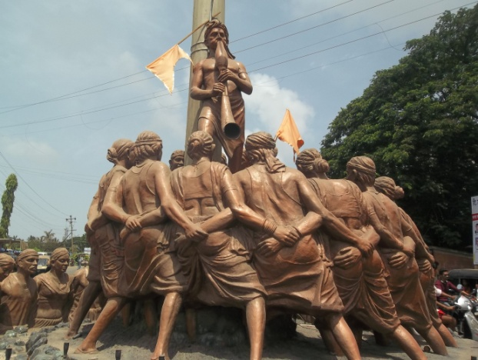
36th Road, RadhasoamiApts, TPS III
Bandra(W), Mumbai 400 050, India
Account No.012801000012770
Swift Code No.IOBAINBB  Contact  Tel/: 0091-22-26455850 : www.reachoutmumbai.org  Aruna, Kendra DolarpadaGirgaum  Tel 091 7768092962  Email: reachoutmumbai@gmail.com | Sparkonte Helfende HandBombay B – Indian Account No. 20479  Blz (bank – code) 34427  Raiffeisen Bank, Austria
Contact persons  Hannelore Huethmayr Möhrergraben 3  A – 4643, Pettenbach Austri  Email: huethmayr.hannelore@a1.net  Dr. AncillaTragler  Email: atragler@gmail.com | 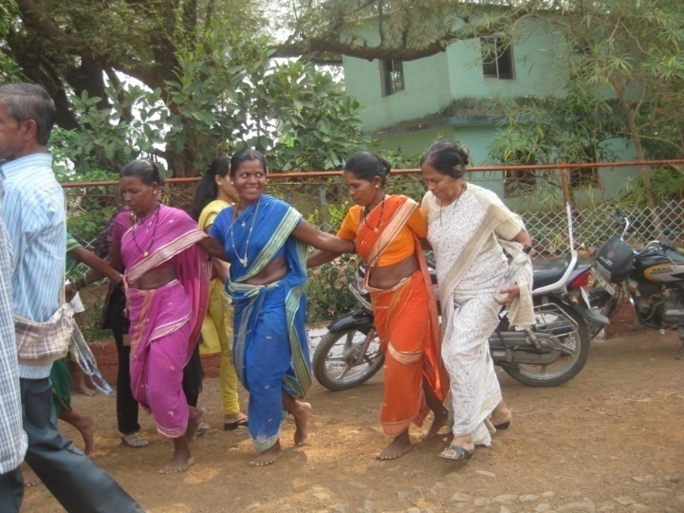
 |  | blz (bank- code) 34427

