10, Samatadeep Bldg, Gr. Floor Aruna Kendra Dolarpada Girgaum
Bandra W Mumbai 400050 Talasari W Palghar MHR INDIA

JULY 2018-JUNE 2019 Newsletter

The Future is Now. How Fast can the World Change? Headlines Time Magazine Feb 2019
Global concerns are many- the rising Temperatures, Trade wars, Migration, Mass shootings, failing economies, internet security to name just a few. Hope is – the rising generation and small groups and organizations around the world demanding a Change leading to sustainability.

India is also facing political unrest, religious intolerance and challenges to its Democracy. The Reach Out Trust since the last 35 years has been striving for a better life for the tribal population in Talasari and slum dwellers in Mumbai. Talasari is in the Maharashtra State, 150 kilometers North of Mumbai. The slums are in Bandra East and West and Khar in the western suburbs of Mumbai.
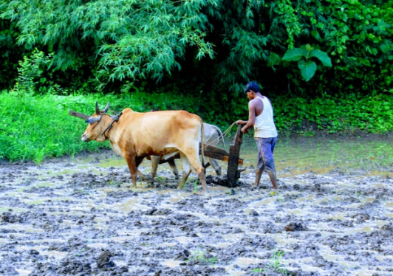
The villagers of Talasari are mostly farmers growing rice as the main and only crop. They also collect forest produce rear a few animals and have poultry.The younger generation work in the industrial belt while some are employed in schools and offices .As the monsoons are in full swing the families will be busy ploughing the land in July then transplanting the rice crop before the harvest in late October .

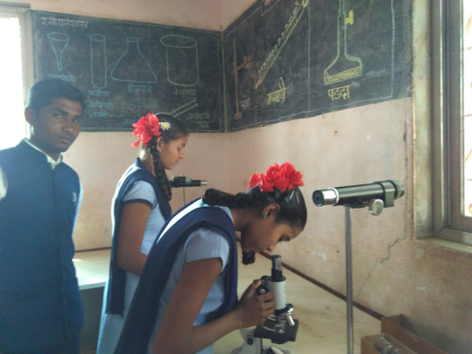
Education Twenty years ago we started a village school in a bamboo hut in Dhangadpada Zari. Today we have the full fledged school inclusive of Primary, Middle and Secondary Sections named the Pushpa Vidhyala School consisting of ten Grades. This school though recognized by the government is not aided by them. It relies on donors like the Reach Out Trust and other generous well wishers like Drs Seitz, Ginza Industrial Trust, local Rotary club and other such organizations .Presently we have 225 children registered this June. This year also marked the 4th successful batch of students completing the 10th grade in April 2019.
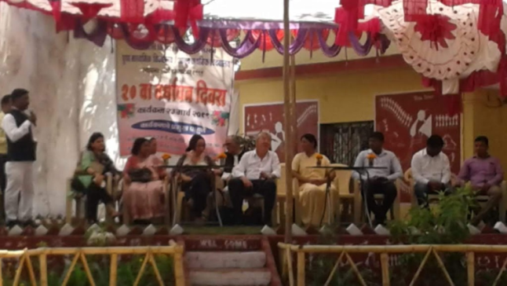
The school has now a functioning science laboratory, computer literacy for middle and high school students, and a play ground for games and physical activities The school children also take part in creative and cultural activities. In March they put up a program of dance, singing and games well enjoyed by parents children and guests who included Reach Out Trust Trustees, Barbara and Wolfgang Seitz donors from Germany, other donors and local officials. The chairman of the Reach Out Trust Father Andrew Rodrigues and Dr Barbara Seitz gave encouraging talks to the children. Dr Ancilla Tragler felicitated the ex students of the school and gave financial scholarships to 18 of them pursuing a college education .The students were all successful in the various streams of Arts Science and Commerce in the last year.
The guests were presented with flowers made with date palm leaves by the school children. The staff and guests who included Trustee Sr Marie Noronha and Mr and Mrs Acharya were then presented with shawls painted with Warli Art by the local artists. Then followed traditional sports activities, creative skill games, delicious snacks and the Community tribal dancing to conclude a very enjoyable program.

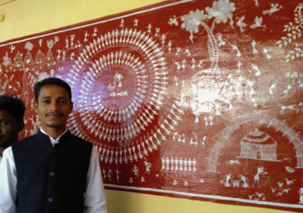
This year the school has been freshly painted and the garden and play ground well maintained by staff and students. The headmistress Ms Urmila Kakad and her staff together with the school Trust administrators Mr Santosh Meghwale and Mr Anil Moda work steadfastly to keep the school functioning well . As there is shortage of space in the school Santosh has provided space in his house for 2 classes. There is also a one common class in the local Zillaparishad ( government) school ‘ where we are paying the teacher’s salary to the benefit of children of both the schools.
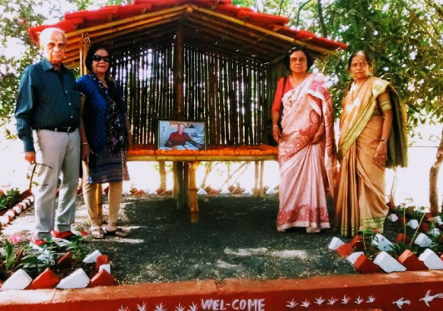
The donors look after payment of salaries of staff and the maintenance of the school.

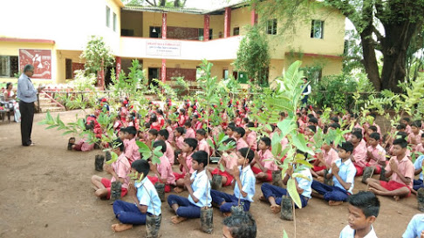
We are proud to say that ex students Ajay Dhangda and Sunil Dhangda are teaching in the school another student Ashok looks after the security and maintenance of the school. Ajay and a few other ex students contributed to the Warli paintings on the school wall. Other ex students have also become teachers in other schools and one has joined the nursing profession and is well placed in a private hospital. We are already reaping the fruits of our efforts in education. Homage was paid to founder member Adolf Tragler and the hall on the first floor was deicated to him.He is well rememember and beloved by one and all.

Environment Some concern for us and the environment is that the Talasari region has been having mild tremors this last year with some damage to the school and our center Aruna Kendra in Dolarpada..The children are also conscious of the environment and its betterment. They planted 22000 seeds in the hills and surrounding areas in the beginning of the monsoons. The local Rotary club also donated 5 fruit trees to each child and staff, Trees included local variety offruit trees like Cashew, Almond and bamboo trees We also repaired the rain harvesting system of the school for maintenance of the school garden of fruits and flowers All efforts to make our world “cleaner and greener “

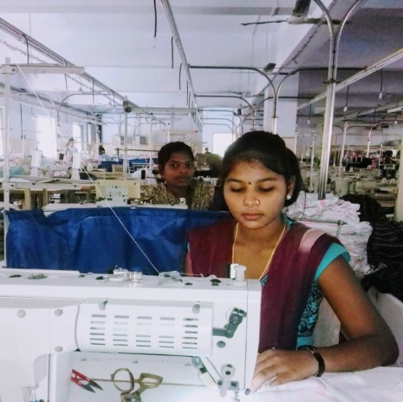
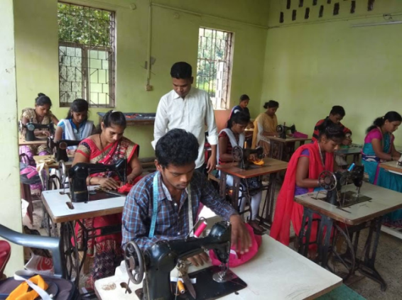
Vocational Training We have many aspiring youth in the search of careers and good jobs. For the last 20 years we have provided training in Tailoring Welding, Electrical, and Computer basics. Some of these students are school drop outs but most have completed 10 to 12 th grade education. In the last year we had 2 batches of tailoring courses for 15-18 students in each batch and 2 batches of 8-10 students in both Welding and Computer basics. These students get a Government recognized certificate after completing the course..
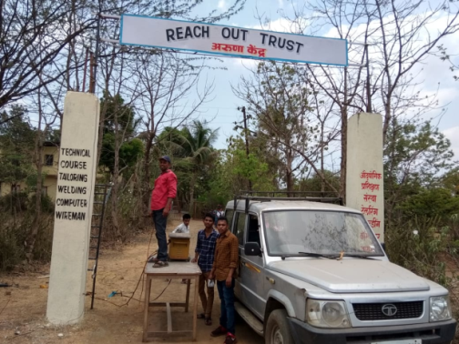
Our technical staff supervisor Sunil Correia and tailoring Instructor Ajay Kondare were involved in placement of jobs for the students This year 17 of the 35 tailoring students and 15 of the 20 the last of welding students obtained employment in surrounding industrial belt the others are l self employed. The students also help in the many maintenance work required for the Office or Trust premises. They were involved in fixing the sign boards at the entrance of Aruna Kendra our center in Dolarpada and making fixtures for the gate and water irrigation system. We did pest control in the office building and welding training room as a preventive measure against termites.

Leadership Training for Youth
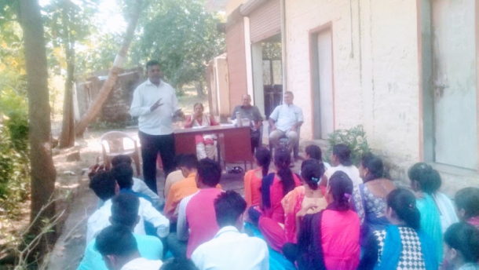
In October we conducted a leadership and sex education Work shop for the youth in our training programs .Sister Marie Noronha and Mrs Effie Acharya together with our staff organized the training with morning and afternoon sessions and lunch in between They had invited Fathers Michael Correia and Jacob Koli from the neighboring parish to conduct the sessions. About 30 students attended and they were enthusiastic and positive about the training

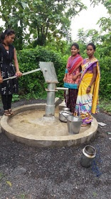
Water management with bore wells For some years villagers having been requesting us to help them get them a proper water supply system. Our staff Sunil and Trustee Dayanand Ambolkar made several visits to the villages and chose 3 villages that had a major water problem with no nearby water resources of rivers or wells. At our center too students need drinking water ,so also villagers in the surrounding area. For this reason 4 bore wells were sanctioned for these 5 areas at our Trustee meeting. The Trustees Sr Marie, Dr Tragler, and Mr and Mrs Acharya too met with the villagers in Girgaum and Dhangadpada to confirm the villagers need and cooperation . A written agreement was made and signed by villagers as to the use of water for common household purposes mainly . They chose a convenient spot on their lands which was also agreed upon by the bore well contractor Sudhakar Kharpade who also had some experience in designing the correct spot for the bore well. We started in March, our staff had to be constantly in touch with the bore well team to sustain their work . They were busy with many other such orders The 4 bore well were finally constructed and the villagers could get water in the heat of the late summer. Most of the wells were bored to about 150 feet in depth The villagers contributed the land and the concrete construction around the well and would also manage the future maintenance of the bore wells..
Sponsoring Children and students in Mumbai We sponsored school and college students fees in the months of February and March. These students were of poor socio economic back ground and they or the parents had chronic medical problems .One such with a medical problem was our ex drivers Ashok Jadav’s wife, who had a sudden stroke. Ashok has severe diabetes with vision problems and had financial difficulties.. The others were 10 children who were of families of migrants from the tribal region of Jharkhand. Dr Tragler visited another 10 children’s families in the slums of Mount Mary Bandra These children had parents with chronic diseases like cancer or HIV. Some were children of single women households. One such a student whose both parents and one sibling had Aids had scored distinctions in the Commerce field and was keen to pursue further studies in Accountancy. Dr Tragler was happy to see some of these families re housed in small flats with water electricity and lift service. Mr Adolf Tragler our founder Trustee had been involved in this housing project. It was very rewarding to see that many of the youth now were now educated or trained and were earning well. Three girls had jobs in nursing professions, others as beauticians, the boys were employed in offices or had trades.

Trust lands and administration The staff spent much time in getting Trust land papers in order to obtain a government survey of the Trust lands. The local authorities are not very helpful. and want to be rewarded for all they do besides the official payments we make. Its is time consuming , expensive and frustrating for all of us. The survey is required for the purpose of getting an Official Non agricultural (N A.) sanction. Sunil and Dayanand spent much time and effort for this after frequent consultations with Dr Tragler and Father Andrew. They have finally obtained the signed survey after almost 4 months and we can now proceed to get the NA certificate.
The Reach Trust continues to strive for a change for the better in the lives of the Tribals of Talasari and slum dwellers in Mumbai.

Special Thanks: We give thanks to all our well-wishers and donors for their interest and donations to our projects. Without their support these projects would not have succeeded. Our appreciation and gratitude also goes to all our family members and friends from Germany, India, Austria and UK.
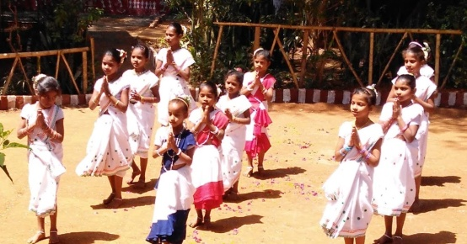
We are grateful to: Drs. Wolfgang & Barbara Sietz (Germany)Mrs. Regine Proebsting, Gaby and Willem Lefeber & team of Indian Hilfe (Germany) We are also thankful for the timely assistance of Sophia Polytechnic Mumbai.and Baraka UK.
We are very grateful to our ex Trustee Dr. Christa Merkes Frei who does the German translation of the newsletter every year.
We also appreciate the assistance of Mr. Rajgopal and Mrs. Effie Acharya and Trustees Sr. Marie Noronha and Fr Andrew Rodrigues, Dayanand Ambolkar , Joseph Keve, Mrs Anadani Thakoor and Ms Marie Noronha .
Our special thanks to Mrs. Hannelore Huethmayr who coordinates the foreign transactions of the Trust and the donations of the Helfende Hand (Austria). Bouquets also to the generous contribution of Dr. Helga Lohmann (Germany) and Herr Fritz Fuhrer Salzburg. Many thanks to the Family Strassmayr, Families Tragler Family Kobler and Missionskreis Pettenbach- Austria for their kind assistance.
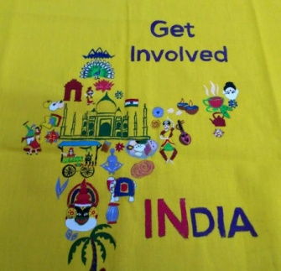
Dr. Ancilla Tragler
Secretary / Trustee Reach Out Trust
Tel: 0091-/9967817028, email: atragler@gmail.com

Reach Out Trust - Website: www.reachoutmumbai.org
Tel: 091 7768092962
Our Bank Name: Indian Overseas Bank
36th Road, Radhasoami Apts, Bandra (W), Mumbai 400050,
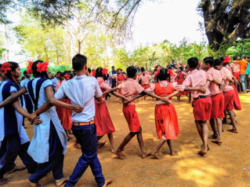
Account No: 012801000012770
Swift Code No: IOBAINBB100028

Contact Person for Foreign contributions:
Hannelore Huethmayr Lärchenweg 10
A – 4644 Scharnstein, Oesterreich (Austria)
email: huethmayr.hannelore@a1.net

Sparkonto in Österreich
Helfende Hand BOMBAY – Indien
RAIFFEISEN Meine Bank – Österreich
BLZ (Bankleitzahl) 34380, BIC: RZOOAT2L380
IBAN: AT42 3438 0000 0382 0479

