Reach Out Trust Offices:

10, SamatadeepBldg, Gr. Floor Aruna Kendra DolarpadaGirgaum
Bandra W Mumbai 400050 TalasariW Palghar District– MHR
INDIA

JULY 2017-JUNE 2018
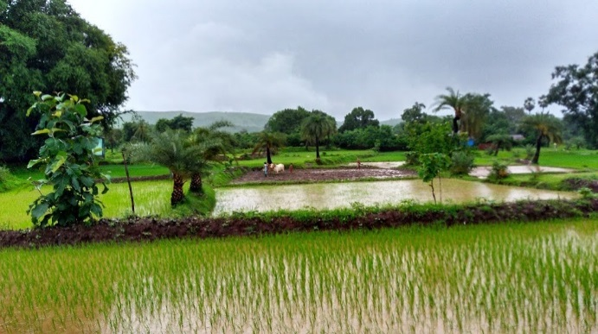
The year 2017 was marked by conflict ,instability and various human crises-but there was a silver lining too. According to the Council of Foreign relation(USA) there was a decline in childhood mortality ,the hole in the earth’s ozone layer was the smallest since 1988, economy improved in the Euro zone ,women’s rights improved and the number of people living in extreme poverty declined from 35% in 1990 to 8.4 %! In India the economic growth depends much on the monsoons which have been predicted to be normal but inevitably there will be some areas of drought and some with floods.
This year 2018 the focus is on universal health coverage for everyone, everywhere in India. The focus is also on affordable care, especially to the most vulnerable. The Reach Out Trust has targeted the vulnerable tribal area of the Talasari West 150 kilometres North of Mumbai Maharashtra and also the poor in the urban slums of Mumbai.
Education and Vocational Training, and overall decreasing poverty levels have been some of the main activities of the Reach Out Trust. These have definitely have a positive effect on health.
Education
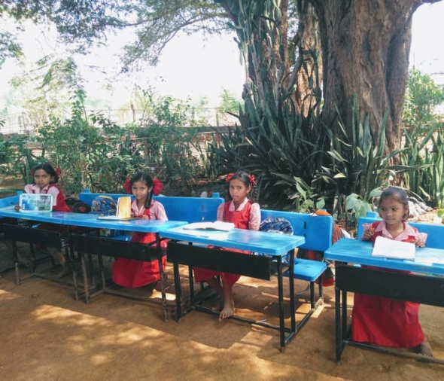
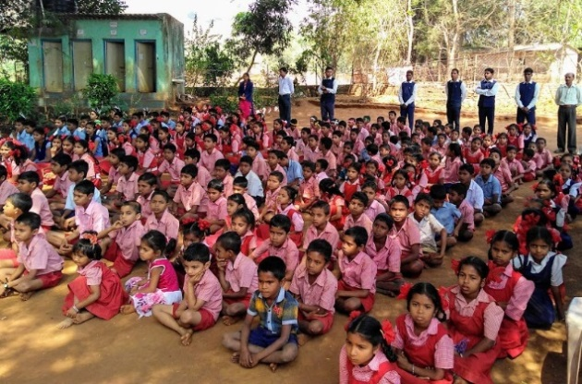
The Tribal children of Talasari are still missing out in a good education and we have focussed on this from early in the program. Initially our efforts were directed towards catering to the dropouts from school and early childhood learning centers. The government programs are now catering to these needs.Now we are focussed on the Pushpa Vidhyala School which is a fully fledged school for the tribal children in Dhangadpada Zari Talasari W in the state of Maharashtra. This year our third batch of students completed the 10th grade with good results and 75% success rate. About 220 children have registered this June in the school.. Reach Out is assisting in payment of salaries of the teachers and maintenance of the school. The school is also assisted by other donors one of which are long term benefactors Drs Barbara & Wolfgang Seitz from Germany. They together with the Reach Out Trust have contributed to the building of the school which is set in a picturesque background of tamarind trees and a floral garden maintained by the children. The school has 6 classrooms , a large hall also used as a classroom, a computer room and an office. Adjoining to the school are kitchen and there are 4 toilets bordering the fence. We have constructed a bore well and a regular well for water supply which are situated outside the school on village land. The water is piped to overhead tanks so that there is continuous water for the school use. . The villagers too make use of the well. For the last 4 years we have electricity and the Trust has provided the school with lights and fans.
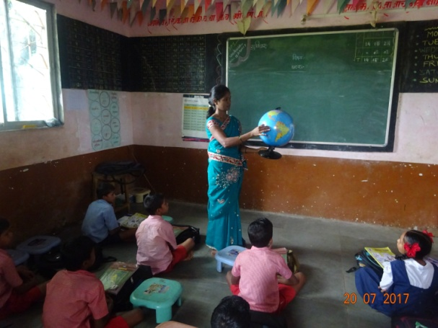
We have twelve teachers including the computer teacher. The computer section has been sponsored by the local Rotary club. The headmistress of the school Ms Urmila Kakad (photo) is also a Trustee of the school and is part of the management. Mr Santosh Meghwale & Mr Anil Moda are the founder members of the school trust and are mainly responsible for the administration of the school. Their education together with 2 other members of the school administrative Trust have all been sponsored by the Reach Out Trust.
The children have participated in the local sports & cultural events. They have also been involved in learning crafts ,folk dance, Warli art, music, craft and physical education of drill and exercises. The school has been provided with musical instruments to perform as a small band. Some sports equipment for cricket, carom & ball games, teaching aids and library books have also been donated by the Reach out Trust. Dr Christa Merkes Frei an ex Trustee also donated some musical instruments and toys to the school. In the monsoons the children take part in tree planting. A few boys in the tenth grade who live in distant villages stay in the school as boarders. Various sports and cultural programs are held through the year by the school staff, like Independence day ,Diwali the festival of lights and Christmas .
This year our donors from Germany Drs Barbara and Wolfgang Seitz visited the school in March . The children put up a welcome drum band and a march past to welcome the guests- the Trustees of the Reach Out Trust and Drs Seitz. A cultural programme of dance & drill followed by speeches by the donor guest Dr Barbara, followed by Sister Marie Noronha and
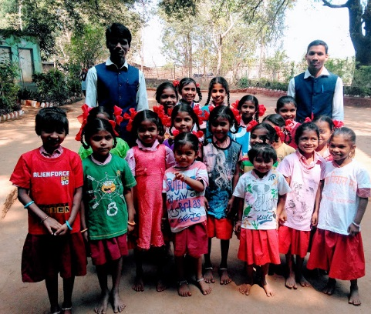
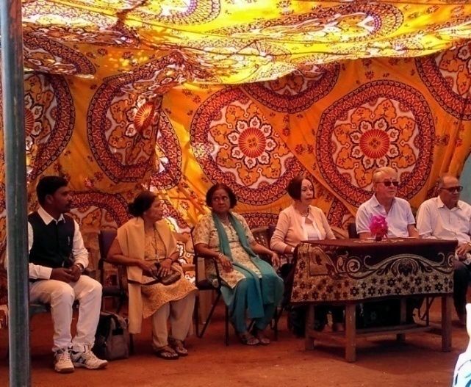
Father Andrew, Reach Out Trustees . Dr Tragler gave out scholarships funding to 11 ex students of the previous year who were studying in college in Arts science & commerce streams .We hope they will form an ex students group who will stay in contact with the school and assist where they can.
The teachers displayed the use of teaching aids on the lawn of the school Later there were gatherings with teachers , the Trustees and the visitor guests. We had also coordinated with the Ratna Nidhi Trust Mumbai who donated clothes for the children for all ages The children proudly displayed their new clothes in the photo.

Vocational Training
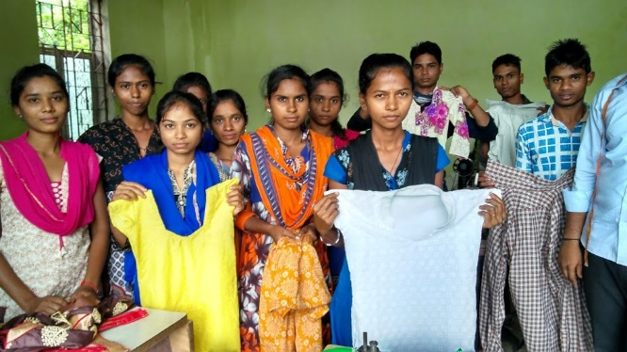
Our vocational training are in 6 month courses in tailoring , welding and we have a government certification for these courses
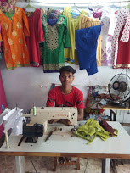
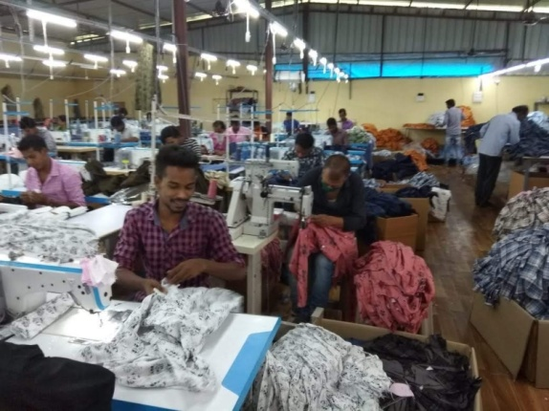
The tailoring course is favoured by the students with 4 batches per year of about 20 students each. The welding had about 10 students We also had 2 batches of 3 months in basic computer training. Sunil Correa is our technical supervisor He and other staff regularly spread the news of the events & courses with posters in the the villages in the vicinity. The tailoring teacher Ajit Kondare is also very professional and much sought after by the youth ready to learn a trade and earn an income. Placement for jobs is an important part of the program. Most (75%) of the tailoring and welding students were taken up by the industrial companies in the vicinity. Other students are self employed as seen in the photo of the young entrepreneur in his tailoring shop. Computer classes are taken up by college students. We are fortunate to get a good teacher living nearby, as earlier this was a big problem. The computers were donated by Baraka UK. We plan to have leadership and personality development workshops for these students as we did in the past years.
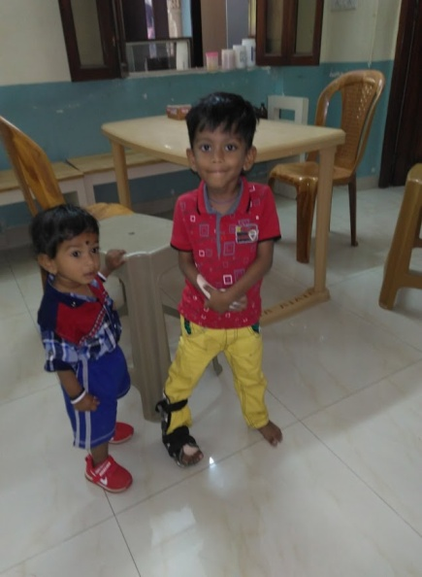
Sponsorship Education Program for Urban Poor
We continue to sponsor children and youth for education in Mumbai . These are from families who live in slums, some are migrants from poor states of India, some have a chronic illness others have parents who have chronic medical problems like Aids, TB and Cancer. Two children included this year was a 5 year old who had a stroke and needs rehabilitation the other has a rare immune disorder who needs a bone marrow transplant. There about 30 children enlisted in this program.
Other Programs
We are in contact with the woman’s savings groups. We are pleased to see income generation training we have given is still bearing fruits. Women have small enterprises in shops ,and are engaged in animal rearing. Trees are distributed for planting in the monsoons. The government health and nutrition programs are functioning.
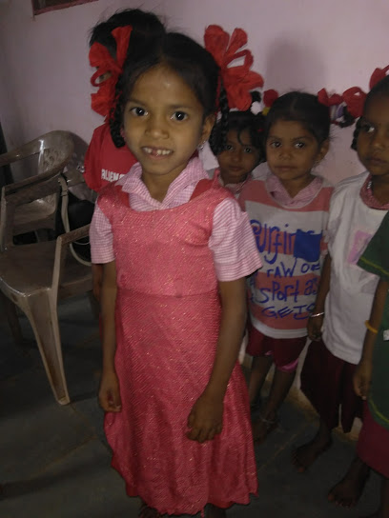
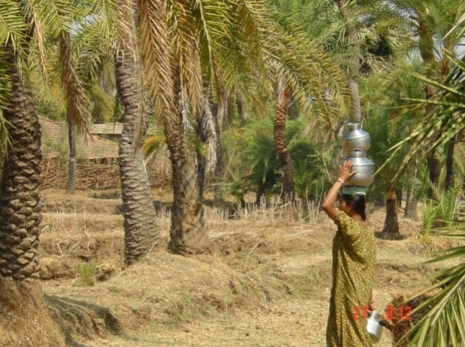
Trust Lands We are completing administrative work on the Trust lands. A government survey is planned. We have a full time employee for maintaining the horticulture on the land. We had a good crop of chikoos (fruit),but mangoes were not so good this year, the wild date trees are common here(photo). The jack fruit tree gave a good crop of fruits which were enjoyed by staff and trustees before they could be stolen. Thefts are common in the area, some groups even tried to cut and steal our teak trees. Luckily our night security stopped them. These groups then tried to threaten our staff. We had to get police protection to get situation under control. We have again applied for bore wells for villagers in need of water supply this year and yet to get a reply. Through The Reach Out Trust we have been able to give the, Warli tribal people specially the children and youth a reason to have hope for the future.

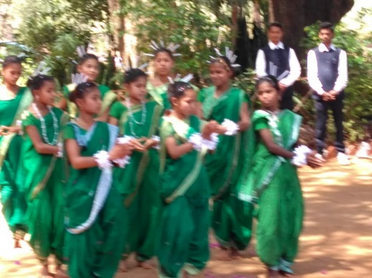
Special Thanks :We give thanks to all our well-wishers and donors for their interest and donations to our projects. Without your support these projects would not have succeeded. Our appreciation and gratitude also goes to all our family members and friends from Germany, India, Austria and UK.
We are grateful to:Drs. Wolfgang & Barbara Sietz (Germany) Mrs. Regine Proebsting, Gaby and Willem Lefeber & team of Indian Hilfe (Germany).
We are also thankful for the timely assistance of Sophia Polytechnic Mumbai.and Baraka UK.
We are very grateful to our ex Trustee Dr. Christa Merkes Frei who does the German translation of the newsletter every year.
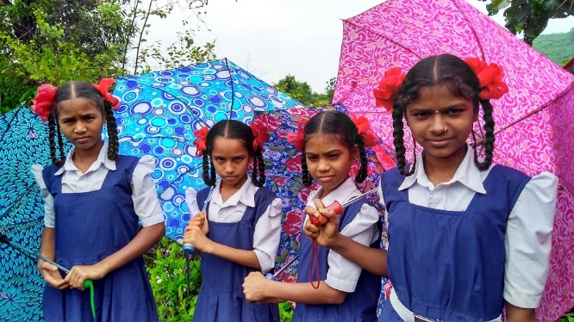
We also appreciate the assistance of Mr. Rajgopal and Mrs. Effie Acharya and Trustees Sr. Marie Noronha and Fr Andrew Rodrigues, Dayanand Ambolkar , Joseph Keve, Mrs Anadani Thakoor and Ms Marie Noronha .
Our special thanks to Mrs. Hannelore Huethmayr who coordinates the foreign transactions of the Trust, and members of Helfende Hand (Austria). Bouquets also to the generous contribution of Dr. Helga Lohmann (Germany) and Herr Fritz Fuhrer Salzburg, Many thanks to the Family Strassmayr, Families Tragler and Missionskreis Pettenbach, Austria for their kind assistance.
Dr. Ancilla Tragler
Secretary / Trustee Reach Out Trust
Tel: 0091-22-26451334/9967817028Email: atragler@gmail.com
Contact Person:for Foreign contributions
Hannelore HuethmayrLärchenweg 10
A – 4644 Scharnstein, OesterreichEmail: huethmayr.hannelore@a1.net
Reach Out Website:www.reachoutmumbai.org
Tel: 091 7768092962Email: reachoutmumbai@gma
Our Bank Name: Indian Overseas Bank
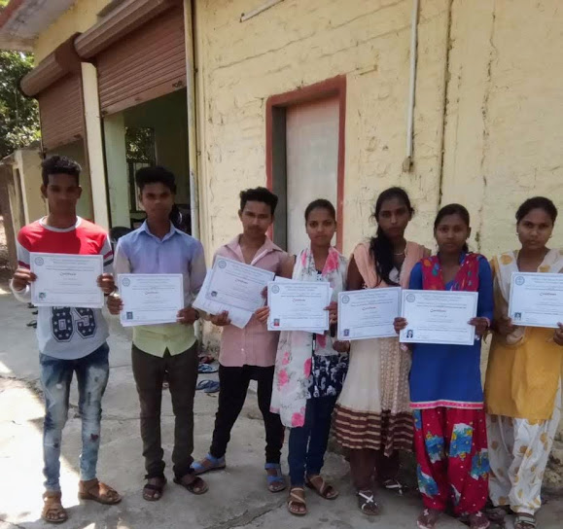
36th Road, Radhasoami Apts, Bandra (W), Mumbai 400 050,
Account No: 012801000012770
Swift Code No: IOBAINBB100028
Sparkonto in Österreich
Helfende Hand BOMBAY – Indien
RAIFFEISEN Meine Bank – Österreich- Konto-Nr. 20479
BLZ (Bankleitzahl) 34380, IBAN: AT42 3438 0000 0382 0479
BIC: RZOOAT2L380

